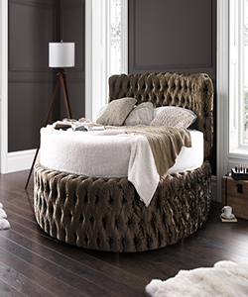

Bed

$500.76

Availability: In stock

Description

The glamour round bed is handmade with absolute affection. The soft crushed velvet and deep accented cushioned buttons create the perfect royal look. This round bed range is available in a wide range of colors and fabrics. The base separates in two halves which certainly makes it easier to access your home.